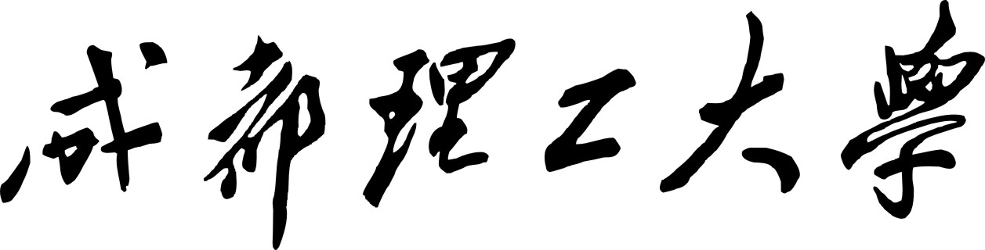

本科生实验报告

实验课程 GIS软件设计与开发
学院名称 地球科学学院
专业名称 地理信息科学
学生姓名 范华燃、雷欢、胡惠菱
学生学号 201401110121、201401110227、201401110127
指导教师 罗智勇
实验地点 D6814
实验成绩
二〇一七年 3月 二〇一七年7月

目录
雅安市芦山~宝山公路风险预警系统 1
一.系统简介 1
二.系统概述 1
三.系统开发人员与分工 1
四.公路风险预警系统核心代码 1
五.系统成果 35

近代名人事件管理系统

一.系统简介
西南科技大学地理信息科学和测绘相关专业师生通过对四川省雅安市芦山至宝山主要公路干线及周边行政区、地理环境和地质灾害等进行了多年的研究，累积了很多研究资料和实际成果，本系统通过对其的研究资料和数据进行汇总分析，实现集中展示，通过相关开发技术实现了成果汇总、公路风险预警、绕行分析等核心功能

二.功能概述
主要功能如下：
（1）汇总西南科技大学对芦山至宝山公路段的多年研究成果，对相关数据（公路风险、区域公路网、行政区等数据）进行加载展示
（2）公路绕行分析，通过对公路障碍点进行处理，通过网络分析，得出两地点的最短距离，从而可以实现在公路受灾阻塞情况下，确定最佳绕行线路
（3）公路预警功能，通过对中国天气网的降水数据进行提取，与已有灾害模型进行栅格数据处理，得出芦山至宝山主干公路的危险情况
（4）天气和降水数据展示，通过良好的界面实现芦山和宝山两县的天气和降水数据的集中展示
（5）基本空间数据查询功能，同时包括空间查询与属性查询，具备良好的查询页面和用户操作
（6）基本GIS控件的操作，如移除图层等
（7）数据展示美观大方，具备图层渲染功能

三.系统架构

开发语言 | C#
集成开发环境 | Visual Studio 2013
数据库 | Access 2010
二次开发平台 | ArcGIS、ArcEngine10.2

…..

四.开发人员与分工

姓名 | 学号 | 负责模块
范华燃 | 201401110121 | 公路绕行分析、空间数据查询，基本GIS控件操作，图层渲染
杨冬 | 201401110105 | 对相关数据的加载展示，公路预警，图层渲染
陈广林 | 201401110111 | 天气和降水数据展示
唐磊 | 201401110115 | 系统测试，数据库

四.核心代码
/// <summary>
/// 网络数据集异常类
/// 2016/12/6 fhr
/// </summary>
class NetworkDbException:Exception
{
public NetworkDbException(string message)
: base(message)
{
}
}
/// <summary>
/// 传输网络分析封装类 2016//11/26 FHR
/// </summary>
public class NormalNetworkUtil
{
/// <summary>
/// 打开工作空间
/// </summary>
/// <param name="strMDBName"></param>
/// <returns></returns>
public static IWorkspace OpenWorkspace(string strMDBName)
{
IWorkspaceFactory pWorkspaceFactory = new AccessWorkspaceFactoryClass();
IWorkspace pWorkspace=null;
try
{
pWorkspace = pWorkspaceFactory.OpenFromFile(strMDBName, 0);
}
catch (Exception e)
{
Debug.Print("打开工作空间出错:"+e.Message);
throw new NetworkDbException("网络数据库打开错误");
}
return pWorkspace;
}
/// <summary>
/// 打开网络数据集
/// </summary>
/// <param name="pWorkspace"></param>
/// <param name="featureDatasetName"></param>
/// <param name="sNDSName"></param>
/// <returns></returns>
public static INetworkDataset OpenNetworkDataset(IWorkspace pWorkspace, string featureDatasetName, string sNDSName)
{
try
{
IFeatureWorkspace pFeatureWorkspace = pWorkspace as IFeatureWorkspace;
if (pFeatureWorkspace == null) return null;
IFeatureDatasetExtensionContainer pFeatureDatasetExtensionContainer = pFeatureWorkspace.OpenFeatureDataset(featureDatasetName) as IFeatureDatasetExtensionContainer;
if (pFeatureDatasetExtensionContainer == null) return null;
IDatasetContainer2 pDatasetContainer2 = pFeatureDatasetExtensionContainer.FindExtension(esriDatasetType.esriDTNetworkDataset) as IDatasetContainer2;
INetworkDataset pNetworkDataset = pDatasetContainer2.get_DatasetByName(esriDatasetType.esriDTAny, sNDSName) as INetworkDataset;
return pNetworkDataset;
}
catch(Exception e)
{
Debug.Print(e.Message);
return null;
}
}
/// <summary>
/// 打开网络数据集
/// </summary>
/// <param name="GDBfileName"></param>
/// <param name="featureDatasetName"></param>
/// <param name="sNDSName"></param>
/// <returns></returns>
public static INetworkDataset OpenNetworkDataset(string GDBfileName, string featureDatasetName, string sNDSName)
{
try
{
IWorkspace pWorkspace = OpenWorkspace(GDBfileName);
IFeatureWorkspace pFeatureWorkspace = pWorkspace as IFeatureWorkspace;
if (pFeatureWorkspace == null) return null;
IFeatureDatasetExtensionContainer pFeatureDatasetExtensionContainer = pFeatureWorkspace.OpenFeatureDataset(featureDatasetName) as IFeatureDatasetExtensionContainer;
if (pFeatureDatasetExtensionContainer == null) return null;
IDatasetContainer2 pDatasetContainer2 = pFeatureDatasetExtensionContainer.FindExtension(esriDatasetType.esriDTNetworkDataset) as IDatasetContainer2;
INetworkDataset pNetworkDataset = pDatasetContainer2.get_DatasetByName(esriDatasetType.esriDTAny, sNDSName) as INetworkDataset;
return pNetworkDataset;
}
catch (Exception ex)
{
Debug.Print(ex.Message);
return null;
}
}

/// <summary>
/// 根据网络数据集创建网络分析上下文
/// </summary>
/// <param name="networkDataset"></param>
/// <returns></returns>
private static INAContext CreateNAContext(INetworkDataset networkDataset)
{
IDENetworkDataset pDENetworkDataset = GetDENetworkDataset(networkDataset);
INASolver pNASolver = new NARouteSolverClass();
INAContextEdit pNAContextEdit = pNASolver.CreateContext(pDENetworkDataset, pNASolver.Name) as INAContextEdit;
pNAContextEdit.Bind(networkDataset, new GPMessagesClass());
return pNAContextEdit as INAContext;
}
/// <summary>
/// 获取IDENetworkDataset
/// </summary>
/// <param name="networkDataset"></param>
/// <returns></returns>
private static IDENetworkDataset GetDENetworkDataset(INetworkDataset networkDataset)
{
IDatasetComponent dsComponent = networkDataset as IDatasetComponent;
return dsComponent.DataElement as IDENetworkDataset;
}

/// <summary>
/// 以图层的方法插入相关元素 如经过站点、障碍点、障碍线、障碍多边形等
/// </summary>
/// <param name="pNAContext">网络分析上下文</param>
/// <param name="strNAClassName">Routes,Stops、Barriers、PolylineBarriers\PolygonBarriers</param>
/// <param name="inputFeatuerClass">要素类</param>
/// <param name="dSnapTolerance">阈值</param>
public static void LoadNANetWorkLocations(INAContext pNAContext, string strNAClassName, IFeatureClass inputFeatuerClass, double dSnapTolerance)
{
INAClass pNAClass;
INamedSet pNamedSet;
pNamedSet = pNAContext.NAClasses;
pNAClass = pNamedSet.get_ItemByName(strNAClassName) as INAClass;
ISpatialFilter filer = new SpatialFilterClass();
filer.WhereClause = "";
int count = inputFeatuerClass.FeatureCount(filer as IQueryFilter);
//删除已存在的元素
pNAClass.DeleteAllRows();
//创建NAClassLoader，设置捕捉容限值
INAClassLoader pNAClassLoader = new NAClassLoaderClass();
pNAClassLoader.Locator = pNAContext.Locator;
if (dSnapTolerance > 0)
{
pNAClassLoader.Locator.SnapTolerance = dSnapTolerance;
}
pNAClassLoader.NAClass = pNAClass;
//字段匹配
INAClassFieldMap pNAClassFieldMap = new NAClassFieldMapClass();
pNAClassFieldMap.CreateMapping(pNAClass.ClassDefinition, inputFeatuerClass.Fields);
pNAClassLoader.FieldMap = pNAClassFieldMap;
//加载要素类数据
int iRows = 0;
int iRowsLocated = 0;
IFeatureCursor pFeatureCursor = inputFeatuerClass.Search(null, true);
pNAClassLoader.Load((ICursor)pFeatureCursor, null, ref iRows, ref iRowsLocated);
((INAContextEdit)pNAContext).ContextChanged();

}
/// <summary>
/// 最短路径分析
/// </summary>
/// <param name="mapControl">地图控件</param>
/// <param name="gdbfileName">数据库文件</param>
/// <param name="featureDatasetName">要素集名字</param>
/// <param name="ndsName">网络数据集名字</param>
/// <param name="featureClasses">参数要素类及其阈值,其中键值包括:Stops(路线经过结点),Barriers,PolylineBarriers,PolygonBarriers</param>
/// <param name="isShowDataBase">是否显示网络数据集</param>
/// <param name="isShowNalayer">是否显示网络分析图层</param>
/// <param name="routeLayer">最近路线图层</param>
public static bool Short_Path(AxMapControl mapControl, string gdbfileName, string featureDatasetName, string ndsName, IDictionary<string, DecorateRouteFeatureClass> featureClasses, bool isShowDataBase, bool isShowNalayer, ref ILayer routeLayer)
{
//首先判断输入的参数要素类是否合法
if (!FeatureClassKeyIsRight(featureClasses))
{
throw new Exception("参数字典错误");
}
// mapControl.ClearLayers();
//打开工作空间
IFeatureWorkspace pFeatureWorkspace = OpenWorkspace(gdbfileName) as IFeatureWorkspace;
if (pFeatureWorkspace == null) { return false; }
//获取网络数据集
INetworkDataset pNetworkDataset = OpenNetworkDataset(pFeatureWorkspace as IWorkspace, featureDatasetName, ndsName);
if (pNetworkDataset == null)
{
Debug.Print("无法获取网络数据集");
return false;
}
//获取网络分析上下文
INAContext pNAContext = CreateNAContext(pNetworkDataset);
//打开节点图层 一般和网络数据集放置在一起 名称是xxx_Junctions
IFeatureClass pVertexFC = pFeatureWorkspace.OpenFeatureClass(ndsName + "_Junctions");
ILayer pLayer=null;
// 显示网络数据集图层
if(isShowDataBase)
{
INetworkLayer pNetworkLayer = new NetworkLayerClass();
pNetworkLayer.NetworkDataset = pNetworkDataset;
pLayer = pNetworkLayer as ILayer;
pLayer.Name = "网络数据集";
mapControl.AddLayer(pLayer, 0);
}
//创建网络分析图层
INALayer naLayer = pNAContext.Solver.CreateLayer(pNAContext);
//显示网络分析图层
if (isShowNalayer)
{
pLayer = naLayer as ILayer;
pLayer.Name = pNAContext.Solver.DisplayName;
pLayer.SpatialReference = mapControl.SpatialReference;
mapControl.AddLayer(pLayer, 0);
IActiveView pActiveView = mapControl.ActiveView;
IMap pMap = pActiveView.FocusMap;
IGraphicsContainer pGraphicsContainer = pMap as IGraphicsContainer;
mapControl.Refresh();
}
INASolver naSolver = pNAContext.Solver;
//插入相关数据
foreach (var value in featureClasses)
{
LoadNANetWorkLocations(pNAContext, value.Key, value.Value.FeatureClass, value.Value.SnapTolerance);
}
//插入经过点
//LoadNANetWorkLocations(pNAContext,"Stops", stopFeatureClass, 30);
//插入障碍点
// LoadNANetWorkLocations(pNAContext, "Barriers", barriesFeatureClass, 30);
IGPMessages gpMessages = new GPMessagesClass();
// SetSolverSettings(pNAContext);
//寻找最短路径
try
{
pNAContext.Solver.Solve(pNAContext, gpMessages, new CancelTrackerClass());
routeLayer = naLayer.get_LayerByNAClassName("Routes");
}
catch (Exception e)
{
Debug.Print("无法找到最短路径:" + e.Message);
return false;
}
mapControl.Refresh();
if (gpMessages != null)
{
for (int i = 0; i < gpMessages.Count; i++)
{
switch (gpMessages.GetMessage(i).Type)
{
case esriGPMessageType.esriGPMessageTypeError:
Debug.Print("错误 " + gpMessages.GetMessage(i).ErrorCode.ToString() + " " + gpMessages.GetMessage(i).Description);
break;
case esriGPMessageType.esriGPMessageTypeWarning:
Debug.Print("警告 " + gpMessages.GetMessage(i).Description);
break;
default:
Debug.Print("信息 " + gpMessages.GetMessage(i).Description);
break;
}
}
}
return true;
}
/// <summary>
/// 判断参数要素类字典是否包括意外值
/// </summary>
/// <param name="featureClasses"></param>
/// <returns></returns>
private static bool FeatureClassKeyIsRight(IDictionary<string, DecorateRouteFeatureClass> featureClasses)
{
List<string> tempArray=new List<string> (){"Stops","Barriers","PolylineBarriers","PolygonBarriers"};
foreach(var value in featureClasses)
{
if (!tempArray.Contains(value.Key))
{
return false;
}
}
return true;
}
/// <summary>
/// 设置解决器 暂时没有使用到
/// 有问题待修正
/// </summary>
/// <param name="pNAContext"></param>
private static void SetSolverSettings(INAContext pNAContext)
{
if (pNAContext.Solver.CanAccumulateAttributes)
{
INASolver naSolver = pNAContext.Solver;
INARouteSolver naRouteSolver = naSolver as INARouteSolver;
naRouteSolver.FindBestSequence = true;
naRouteSolver.PreserveFirstStop = true;
naRouteSolver.PreserveLastStop = false;
naRouteSolver.UseTimeWindows = false;
naRouteSolver.OutputLines = esriNAOutputLineType.esriNAOutputLineTrueShapeWithMeasure;
INASolverSettings2 naSolverSettings = naSolver as INASolverSettings2;
IStringArray restrictions = naSolverSettings.RestrictionAttributeNames;
restrictions.Add("Oneway");
naSolverSettings.RestrictionAttributeNames = restrictions;
//基于上述设置更新Solver
naSolver.UpdateContext(pNAContext, GetDENetworkDataset(pNAContext.NetworkDataset), new GPMessagesClass());

}
}
}
public class RainMessage
{
public string initByAreaNameAndDate(string AreaName,DateTime date)
{
//string AreaID=
string AreaID = Common.DBHander.ReturnDataSet("select AreaID from Area where AreaName='" + AreaName+"'").Tables[0].Rows[0]["AreaID"].ToString();
int count = Common.DBHander.ReturnSqlResultCount("select ReacordID from AllDayRanis where AreaID='" + AreaID + "' and " + "TheDay='" + date+"'");
if (count == 0)
{
string insertString = "insert into AllDayRanis (AreaID,TheDay)" + "vaules (\"" + AreaID + "\"" + ",\"" + date + "\")";
Common.DBHander.ExeSQL(insertString);
}
return AreaID;
}
/// <summary>
/// 雨量信息录入
/// </summary>
/// <param name="AreaName"></param>
/// <param name="date"></param>
/// <param name="rains">雨量</param>
public bool EnterRanisMessage(string AreaName, DateTime date,int rains,int timeHour)
{
string dateString=date.ToString("yyyy/MM/dd");
string AreaID = Common.DBHander.ReturnDataSet("select AreaID from Area where AreaName='" + AreaName + "'").Tables[0].Rows[0]["AreaID"].ToString();
// string getReacordID = "select ReacordID from AllDayRanis where AreaID='" + AreaID + "' and " + "TheDay='" + dateString + "'";//遇到找不到表AllDayRanis或查询的错误
string getReacordID = string.Format("SELECT ReacordID FROM AllDayRains where AreaID='{0}' and TheDay=#{1}#", AreaID, dateString);//access sql 中#时间# 才能表示时间
DataTable dt = Common.DBHander.ReturnDataSet(getReacordID).Tables[0];
string updateString = "";
int ReacordID=0;
if(dt==null||dt.Rows.Count==0)
{
string insertString = "insert into AllDayRains (AreaID,TheDay)" + "values (\"" + AreaID + "\"" + ",\"" + dateString + "\")";
Common.DBHander.ExeSQL(insertString);
updateString = string.Format("update AllDayRains set V{0}='{1}' where AreaID='{2}' and TheDay=#{3}#", timeHour, rains, AreaID, dateString);
}
else
{
ReacordID = Convert.ToInt32(Common.DBHander.ReturnDataSet(getReacordID).Tables[0].Rows[0]["ReacordID"]);
updateString = string.Format("update AllDayRains V{0}='{1}' where ReacordID='{2}'", timeHour, rains, ReacordID);

}
return Common.DBHander.ExeSQL(updateString);
}
}
public partial class LayerMangerView : Form
{
//定义栅格、矢量路径
string rasterPath = null;
string shapePath = null;
private List<string> LayerNameList;
private List<string> LayerPathList;

private bool isLoad = true;//为了初始加载时不把底图清空
public LayerMangerView()
{
InitializeComponent();
}

public LayerMangerView(ref List<string> LayerPathList)
{
InitializeComponent();
LayerNameList = new List<string>();
getallLayers();
exCheckedListBox1.DataSource = LayerNameList;
this.LayerPathList = LayerPathList;
judeLayer();
}
//将图层名加载到exCheckedListBox1中
private void getallLayers()
{
switch (MainFrom.WhichChecked)//根据点击模块不同赋予不同的数据途径
{
case 1:
rasterPath = Common.BaserasterPath;
shapePath = Common.BaseshapePath;
break;
case 2:
rasterPath = Common.conditionRaster;
shapePath = Common.conditionShape;
break;
case 3:
rasterPath = Common.conditionAllRaster;
shapePath = Common.conditionAllShape;
break;
//case 2:
// rasterPath = Common.GeoDisasterrasterPath;
// shapePath = Common.GeoDisastershapePath;
// break;
//case 3:
// rasterPath = Common.RoadrasterPath;
// shapePath = Common.RoadshapePath;
// break;
//case 4:
// rasterPath = Common.EcologyrasterPath;
// shapePath = Common.EcologyshapePath;
//break;
default:
break;
}
//加载栅格底图
DirectoryInfo Rasfolder = new DirectoryInfo(rasterPath);
FileInfo[] fileInfos = Rasfolder.GetFiles();
List<string> RasfileType = new List<string>();
RasfileType.Add(".jpg");
//fileType.Add(".shp");
RasfileType.Add(".img");
RasfileType.Add(".tif");
foreach (FileInfo file in fileInfos)
{
//string name = file.Name;
//这里需要加上判断是否可以成为图层数据源的代码 如：图片，矢量文件
string ardess = file.Name.Substring(file.Name.LastIndexOf("."));
if (RasfileType.Contains(ardess))
{ LayerNameList.Add(file.Name); }
}
//加载矢量底图
DirectoryInfo Shasfolder = new DirectoryInfo(shapePath);
FileInfo[] fileInfo2 = Shasfolder.GetFiles();
foreach (FileInfo file in fileInfo2)
{
if (file.Name.Substring(file.Name.LastIndexOf(".")) == ".shp")
{
LayerNameList.Add(file.Name);
}
}
}
//若果已经有图层,则相应的chexbox项应该被选中
private void judeLayer()
{
int count = MainFrom.m_mapControl.LayerCount;
if (count == 0) return;
for (int i = 0; i < count; i++)
{
ILayer pGL = MainFrom.m_mapControl.get_Layer(i);
if (pGL is IGroupLayer)
{
ICompositeLayer pGroupLayer = pGL as ICompositeLayer;
for (int j = 0; j < pGroupLayer.Count; j++)
{
ILayer pCompositeLayer;
pCompositeLayer = pGroupLayer.get_Layer(j);
for (int y = 0; y < exCheckedListBox1.Items.Count; y++)
{
string layerName = exCheckedListBox1.Items[y].ToString();
int index = layerName.LastIndexOf(".");
if (layerName.Substring(index) == ".shp")
layerName = layerName.Substring(0, index);
if (layerName == pCompositeLayer.Name)
{
//后台选中 改变checkState
exCheckedListBox1.SetItemChecked(y, true);
}
}
}
}
else
{
for (int y = 0; y < exCheckedListBox1.Items.Count; y++)
{
string layerName = exCheckedListBox1.Items[y].ToString();
int index = layerName.LastIndexOf(".");
if (layerName.Substring(index) == ".shp") layerName = layerName.Substring(0, index);
if (layerName == pGL.Name)
{
//后台选中 改变checkState
exCheckedListBox1.SetItemChecked(y, true);
}
}
}

}

}

private void ok_Click(object sender, EventArgs e)
{
this.Close();
}

private void exCheckedListBox1_SelectedIndexChanged_1(object sender, EventArgs e)
{
Boolean IsEqual = false;//判断是否已经存在此图层
int i = exCheckedListBox1.SelectedIndex;
var selectLayer = exCheckedListBox1.SelectedItem;
//这里还可以用循环的方法 this.myCheckedlistBox.GetItemChecked(i)
if (exCheckedListBox1.CheckedItems.Contains(selectLayer))
{
string fullPath = selectLayer.ToString();
if (fullPath.Substring(fullPath.LastIndexOf(".")) == ".shp")
{
fullPath = shapePath + fullPath;//这里发现+=和普通写法还是有区别的
//利用"\\"将文件路径分成两部分
int Position = fullPath.LastIndexOf("\\");
//文件目录
string FilePath = fullPath.Substring(0, Position);
//
string ShpName = fullPath.Substring(Position + 1);
IWorkspaceFactory pWF;
pWF = new ShapefileWorkspaceFactory();
IFeatureWorkspace pFWS;
pFWS = (IFeatureWorkspace)pWF.OpenFromFile(FilePath, 0);
IFeatureClass pFClass;
pFClass = pFWS.OpenFeatureClass(ShpName);
IFeatureLayer pFLayer;
pFLayer = new FeatureLayer();
pFLayer.FeatureClass = pFClass;
pFLayer.Name = pFClass.AliasName;
// MainFrom.m_mapControl.Refresh(esriViewDrawPhase.esriViewGeography, null, null);
if(pFLayer.Name=="公路网")
{
RouteLayerUtil.SetRouteLayerStyle(pFLayer);
}
IsEqual = Common.InsertShapeLayer(IsEqual,(ILayer)pFLayer);
if (pFLayer.Name == "聚落")
{
LayerManager.ClassBreaksMap(pFLayer, "rkmidu", 5);
}
if (pFLayer.Name == "行政区")
{
LayerManager.UniqueValueRenderer(pFLayer, "name");
}
if (pFLayer.Name == "乡村点")
{
LayerManager.SetFeaturePictureSymbol(pFLayer, Common.CountryPointImagePath, 15);
}
//选择数据源
MainFrom.toolComboBox.Items.Add(pFLayer.Name);
MainFrom.m_pTocControl.Update();
}
else
{
fullPath = rasterPath + fullPath;
//这里将RasterLayerClass改为RasterLayer 即可以嵌入互操作类型 下同
IRasterLayer rasterLayer = new RasterLayer();
rasterLayer.CreateFromFilePath(fullPath);
// IRaster ir = (IRaster) rasterLayer;
IsEqual = Common.InsertLayer(IsEqual, rasterLayer);
MainFrom.m_pTocControl.Update();
}
}
else
{
string layerName = selectLayer.ToString();
isLoad = true;
if (layerName.Substring(layerName.LastIndexOf(".")) == ".shp")
{
//选择数据源
layerName = layerName.Substring(0, layerName.LastIndexOf("."));
MainFrom.toolComboBox.Items.Remove(layerName);
}
try
{
//这里需要注意的是矢量文件在图层中没有后缀名 而栅格文件在图层中有后缀名 如.tif
MainFrom.m_mapControl.Map.DeleteLayer(LayerManager.returnIndexByLayerName(MainFrom.m_mapControl, layerName));
MainFrom.m_mapControl.Refresh();
MainFrom.m_pTocControl.Update();
}
catch (Exception ex)
{

}

}
}

private void LayerMangerView_Load(object sender, EventArgs e)
{
exCheckedListBox1.Items.Clear();
LayerNameList = new List<string>();
getallLayers();
int i = MainFrom.m_mapControl.LayerCount;
exCheckedListBox1.DataSource = LayerNameList;//为什么这一句就把图层清空了呢 //找到原因 ：果然是应为exCheckedListBox1_SelectedIndexChanged_1事件，赋值的时候在底层执行了，我们看不见
//foreach (var t in LayerNameList)
//{
// exCheckedListBox1.Items.Add(t);
//} 这里改为循环赋值解决了上面的问题
int y = MainFrom.m_mapControl.LayerCount;
judeLayer();
exCheckedListBox1.SelectedIndexChanged += exCheckedListBox1_SelectedIndexChanged_1;
}

private void button1_Click(object sender, EventArgs e)
{
if (openFileDialog1.ShowDialog() == DialogResult.OK)
{
string[] fileNames = openFileDialog1.FileNames;
AddFileToMapControl(fileNames);
}
}
/// <summary>
/// 添加图层到mapcontrol当中
/// </summary>
/// <param name="fileNames"></param>
private void AddFileToMapControl(string []fileNames)
{
foreach(var fileName in fileNames)
{
try
{
ILayer layer = null;
string extension = System.IO.Path.GetExtension(fileName);
if (extension == ".shp")
{
layer = ShapeSimpleHelper.OpenFile(fileName);
}
else if (extension == ".tif")
{
layer = RasterSimpleHelper.OpenRasterFile(fileName);
}
MainFrom.m_mapControl.AddLayer(layer);
}
catch(Exception e)
{
Debug.Print(e.Message);
}
}
}
}
/// <summary>
/// 表格数据建立
/// </summary>
/// <param name="dt">数据源</param>
private void CreateTable(DataTable dt)
{
//让各列头禁止移动
gridView1.OptionsCustomization.AllowColumnMoving = false;
//让各列头禁止排序
gridView1.OptionsCustomization.AllowSort = false;
//去掉上面的筛选条
gridView1.OptionsView.ShowGroupPanel = false;
//禁止各列头改变列宽
gridView1.OptionsCustomization.AllowColumnResizing = false;
this.gridView1.IndicatorWidth = 100;
//不显示内置的导航条。
gridControl1.UseEmbeddedNavigator = false;

for (int i = 0; i < dt.Rows.Count; i++)
{
if (String.IsNullOrEmpty(dt.Rows[i]["dtime3hour"].ToString()))
{
dt.Rows.RemoveAt(i);
i--;
}
}

gridControl1.DataSource = dt;
}

/// <summary>
/// 未来天气预报
/// </summary>
/// <param name="dt">数据源</param>
private void CreateNewChart(DataTable dt)
{
chartControl1.DataSource = dt;
chartControl2.Series.Clear();
#region Series
//创建几个图形的对象
newRains = CreateSeries("降雨量(mm)", ViewType.Bar, dt, "dtime3hour", "rains");
newTemperature = CreateSeries("温度(℃)", ViewType.Line, dt, "dtime3hour", "temperature");
newWindspeed = CreateSeries("风速(m/s)", ViewType.Line, dt, "dtime3hour", "wind");
#endregion

newRains.View.Color = Color.GreenYellow;
newRains.ArgumentScaleType = ScaleType.Qualitative;

chartControl1.Series.Add(newRains);
((BarSeriesView)newRains.View).BarWidth = 0.2;
XYDiagram diagram = (XYDiagram)chartControl1.Diagram;
diagram.AxisY.Title.Visible = true;
diagram.AxisY.Title.Alignment = StringAlignment.Far;
diagram.AxisY.Title.Text = newRains.Name;
diagram.AxisY.Title.Antialiasing = true;
diagram.AxisY.Title.Font = new Font("宋体", 9.0f);
diagram.AxisY.Title.TextColor = Color.Green;
diagram.AxisY.Label.Visible = true;
diagram.AxisY.Label.TextColor = Color.Green;
diagram.AxisY.Color = Color.Green;
((XYDiagram)chartControl1.Diagram).EnableAxisXZooming = true;

newlist = new List<Series>() { newTemperature, newWindspeed };
chartControl1.Series.AddRange(newlist.ToArray());
chartControl1.Legend.Visibility = DefaultBoolean.False;

//十字线参数设置
chartControl1.CrosshairOptions.ShowArgumentLabels = false;//移动鼠标时动态显示Y轴数据标签
chartControl1.CrosshairOptions.ShowArgumentLine = true;//显示Y轴线
chartControl1.CrosshairOptions.ShowValueLabels = false;//移动鼠标时动态显示X轴数据标签
chartControl1.CrosshairOptions.ShowValueLine = false;//显示X轴线

List<Color> colorList = new List<Color> { Color.Blue, Color.Green, Color.Red };
for (int i = 0; i < newlist.Count; i++)
{
newlist[i].View.Color = colorList[i];
CreateAxisY(newlist[i], chartControl1, MarkerKind.Circle, true, i);
}
}

/// <summary>
/// 过去24小时天气展示
/// </summary>
/// <param name="dt">数据源</param>
private void CreateOldChart(DataTable dt)
{
chartControl2.DataSource = dt;
chartControl2.Series.Clear();
#region Series
//创建几个图形的对象
oldRain1h = CreateSeries("降雨量(mm)", ViewType.Bar, dt, "Hourtime", "rain1h");
oldTemperature = CreateSeries("温度(℃)", ViewType.Spline, dt, "Hourtime", "temperature");
oldHumidity = CreateSeries("湿度(%)", ViewType.Spline, dt, "Hourtime", "humidity");
oldWindspeed = CreateSeries("风速(m/s)", ViewType.Line, dt, "Hourtime", "windSpeed");
#endregion

oldRain1h.View.Color = Color.GreenYellow;
oldRain1h.ArgumentScaleType = ScaleType.Qualitative;
((BarSeriesView)oldRain1h.View).BarWidth = 0.8;
chartControl2.Series.Add(oldRain1h);
XYDiagram diagram = (XYDiagram)chartControl2.Diagram;
diagram.AxisY.Title.Visible = true;
diagram.AxisY.Title.Alignment = StringAlignment.Far;
diagram.AxisY.Title.Text = oldRain1h.Name;
diagram.AxisY.Title.Antialiasing = true;
diagram.AxisY.Title.Font = new Font("宋体", 9.0f);
diagram.AxisY.Title.TextColor = Color.Green;
diagram.AxisY.Label.Visible = true;
diagram.AxisY.Label.TextColor = Color.Green;
diagram.AxisY.Color = Color.Green;
((XYDiagram)chartControl2.Diagram).EnableAxisXZooming = true;

oldlist = new List<Series>() { oldTemperature, oldHumidity, oldWindspeed };
chartControl2.Series.AddRange(oldlist.ToArray());
chartControl2.Legend.Visibility = DefaultBoolean.False;

//十字线参数设置
chartControl2.CrosshairOptions.ShowArgumentLabels = false;//移动鼠标时动态显示Y轴数据标签
chartControl2.CrosshairOptions.ShowArgumentLine = true;//显示Y轴线
chartControl2.CrosshairOptions.ShowValueLabels = false;//移动鼠标时动态显示X轴数据标签
chartControl2.CrosshairOptions.ShowValueLine = false;//显示X轴线

List<MarkerKind> markerList = new List<MarkerKind> { MarkerKind.Circle, MarkerKind.Diamond, MarkerKind.Triangle };
List<bool> boolList = new List<bool> { true, true, true };
List<Color> colorList = new List<Color> { Color.Blue, Color.Green, Color.Red };

for (int i = 0; i < oldlist.Count; i++)
{
oldlist[i].View.Color = colorList[i];
CreateAxisY(oldlist[i], chartControl2, markerList[i], boolList[i], i);
}
}

/// <summary>
/// 根据数据创建一个图形展现
/// </summary>
/// <param name="caption">图形标题</param>
/// <param name="viewType">图形类型</param>
/// <param name="dt">数据DataTable</param>
/// <param name="xBindName">x轴绑定数据</param>
/// <param name="yBindName">y轴绑定数据</param>
/// <returns></returns>
private Series CreateSeries(string caption, ViewType viewType, DataTable dt, string xBindName, string yBindName)
{
series = new Series(caption, viewType);
series.ArgumentScaleType = ScaleType.Qualitative;
series.LabelsVisibility = DefaultBoolean.True;//显示标注标签
double value = 0.0;//参数值
string argument = "";//参数名称
int length = dt.Rows.Count;
for (int i = 0; i < length; i++)
{
try
{
switch (xBindName)
{
//OneHourWeather
case "Hourtime":
if ((Convert.ToDateTime(dt.Rows[i][xBindName])).ToString("HH:mm").Equals("00:00"))
{
argument = dt.Rows[i][xBindName].ToString().Split(' ')[0].ToString();
}
else
{
argument = String.Format("{0}点", dt.Rows[i][xBindName].ToString().Split(' ')[1].Split(':')[0].ToString());
}
break;
//ForecastWeather
case "dtime3hour":
argument = dt.Rows[i][xBindName].ToString();
break;
default:
break;
}

switch (yBindName)
{
//ForecastWeather
case "temperature":
if (dt.Rows[i][yBindName].ToString().Contains('℃'))
{
value = Convert.ToDouble(dt.Rows[i][yBindName].ToString().Split('℃')[0]);
}
else
{
if (dt.Rows[i][yBindName].ToString().Equals("9999.0"))
{
dt.Rows.RemoveAt(i);
length--;
}
else
{
value = Convert.ToDouble(dt.Rows[i][yBindName].ToString());
}
}
break;
case "rains":
value = dt.Rows[i][yBindName].Equals("无降水") ? 0.0 : Convert.ToDouble(dt.Rows[i][yBindName].ToString().Split('毫')[0]);
break;
case "wind":
value = Convert.ToDouble(dt.Rows[i][yBindName].ToString().Split('米')[0]);
break;
//OneHourWeather
case "rain1h":
if (dt.Rows[i][yBindName].ToString().Equals("9999.0"))
{
value = Convert.ToDouble(dt.Rows[i - 1][yBindName].ToString());
}
else
{
value = Convert.ToDouble(dt.Rows[i][yBindName].ToString());
}
break;
case "humidity":
if (dt.Rows[i][yBindName].ToString().Equals("9999.0"))
{
value = Convert.ToDouble(dt.Rows[i - 1][yBindName].ToString());
}
else
{
value = Convert.ToDouble(dt.Rows[i][yBindName].ToString());
}
break;
case "windSpeed":
if (dt.Rows[i][yBindName].ToString().Equals("9999.0"))
{
value = Convert.ToDouble(dt.Rows[i - 1][yBindName].ToString());
}
else
{
value = Convert.ToDouble(dt.Rows[i][yBindName].ToString());
}
break;
default:
break;
}
series.Points.Add(new SeriesPoint(argument, value));
}
catch (Exception ex)
{
throw new Exception(ex.ToString());
}

}
return series;
}

/// <summary>
/// 创建图表的第二坐标系
/// </summary>
/// <param name="series">Series对象</param>
/// <returns></returns>
private SecondaryAxisY CreateAxisY(Series series, ChartControl chartcontrol, MarkerKind type, bool label, int i)
{
if (newAxisYList.Count < 3 && oldAxisYList.Count < 3)
{
myAxis = new SecondaryAxisY(series.Name);
((XYDiagram)chartcontrol.Diagram).SecondaryAxesY.Add(myAxis);
((XYDiagram)chartcontrol.Diagram).EnableAxisXZooming = true;
((LineSeriesView)series.View).AxisY = myAxis;
//定义线条上点的标识形状是否需要
((LineSeriesView)series.View).LineMarkerOptions.Visible = true;
//定义线条上点的标识形状
((LineSeriesView)series.View).LineMarkerOptions.Kind = type;
//显示X、Y轴上面的交点的值
((PointSeriesLabel)series.Label).Visible = label;
//线条的类型，虚线，实线
((LineSeriesView)series.View).LineStyle.DashStyle = DashStyle.Solid;

myAxis.Title.Text = series.Name;
myAxis.Title.Alignment = StringAlignment.Far; //顶部对齐
myAxis.Title.Visible = true; //显示标题
myAxis.Title.Font = new Font("宋体", 9.0f);

Color color = series.View.Color;//设置坐标的颜色和图表线条颜色一致

myAxis.Title.TextColor = color;
myAxis.Label.TextColor = color;
myAxis.Color = color;

switch (chartcontrol.Name.ToString())
{
case "chartControl1":
newAxisYList.Add(myAxis);
break;
case "chartControl2":
oldAxisYList.Add(myAxis);
break;
default:
break;
}
}
else
{
switch (chartcontrol.Name.ToString())
{
case "chartControl1":
((LineSeriesView)series.View).AxisY = newAxisYList[i];
//定义线条上点的标识形状是否需要
((LineSeriesView)series.View).LineMarkerOptions.Visible = true;
//定义线条上点的标识形状
((LineSeriesView)series.View).LineMarkerOptions.Kind = MarkerKind.Circle;
//显示X、Y轴上面的交点的值
((PointSeriesLabel)series.Label).Visible = true;
//线条的类型，虚线，实线
((LineSeriesView)series.View).LineStyle.DashStyle = DashStyle.Solid;
break;
case "chartControl2":
((LineSeriesView)series.View).AxisY = oldAxisYList[i];
//定义线条上点的标识形状是否需要
((LineSeriesView)series.View).LineMarkerOptions.Visible = true;
//定义线条上点的标识形状
((LineSeriesView)series.View).LineMarkerOptions.Kind = MarkerKind.Circle;
//显示X、Y轴上面的交点的值
((PointSeriesLabel)series.Label).Visible = true;
//线条的类型，虚线，实线
((LineSeriesView)series.View).LineStyle.DashStyle = DashStyle.Solid;
break;
default:
break;
}
}

return myAxis;
}

/// <summary>
/// 读取数据存为table
/// </summary>
/// <param name="sqlStr">SQL语句</param>
/// <returns></returns>
private DataTable getDataTable(string sqlStr)
{
OleDbConnection con = new OleDbConnection(strFilePath);
con.Open();
OleDbDataAdapter da = new OleDbDataAdapter(sqlStr, con);
DataTable _dt = new DataTable();
try
{
da.Fill(_dt);
}
catch (Exception ex)
{
throw new Exception(ex.ToString());
}
finally
{
con.Close();
con.Dispose();
da.Dispose();
}

return _dt;
}

/// <summary>
/// 为表格添加行标题
/// </summary>
/// <param name="sender"></param>
/// <param name="e"></param>
private void gridView1_CustomDrawRowIndicator(object sender, DevExpress.XtraGrid.Views.Grid.RowIndicatorCustomDrawEventArgs e)
{
e.Appearance.TextOptions.HAlignment = DevExpress.Utils.HorzAlignment.Center;
e.Appearance.Font = new Font("宋体", 10, FontStyle.Bold);
if (e.Info.IsRowIndicator)
{
if (e.RowHandle >= 0)
{
e.Info.DisplayText = dt_Grid.Rows[e.RowHandle]["dtime3hour"].ToString();
}
else if (e.RowHandle < 0 && e.RowHandle > -1000)
{
e.Info.Appearance.BackColor = System.Drawing.Color.AntiqueWhite;
e.Info.DisplayText = "G" + e.RowHandle.ToString();
}
}
}

private void comboBoxEdit_Area_SelectedIndexChanged(object sender, EventArgs e)
{
if (comboBoxEdit_Area.Text.Equals("芦山县"))
{
AreaId = 1;
}
else
{
AreaId = 2;
}
}

private void simpleButton1_Click(object sender, EventArgs e)
{
//day1 = String.Format("{0}日", comboBoxEdit_Date.Text.Split('-')[2].ToString());
//day2 = String.Format("{0}日", (Convert.ToDateTime(comboBoxEdit_Date.Text.ToString()).AddDays(1).ToString("yyyy-mm-dd").Split('-')[2].ToString()));
//day1 = (Convert.ToDateTime(comboBoxEdit_Date.Text)).AddDays(1).ToString("yyyy-MM-dd");
//day2 = (Convert.ToDateTime(comboBoxEdit_Date.Text)).AddDays(5).ToString("yyyy-MM-dd");
day1 = NowTime.ToString("yyyy-MM-dd");
day2 = NowTime.AddDays(6).ToString("yyyy-MM-dd");

ChartSqlStr = String.Format("SELECT ID,dtime3hour,temperature,rains,wind FROM ForecastWeather WHERE AreaID = {0} AND timedate7 = #{1}#", AreaId, comboBoxEdit_Date.Text);
//GridSqlStr = String.Format("SELECT dtime3hour,temperature,rains,wind,windd,yl,xdsd FROM ForecastWeather WHERE AreaID = {0} ORDER BY ID", AreaId);
GridSqlStr = String.Format("SELECT ID,dtime3hour,temperature,rains,wind,windd,yl,xdsd FROM ForecastWeather WHERE AreaID = {0} AND timedate7 BETWEEN #{1}# AND #{2}# ORDER BY ID ASC", AreaId, day1, day2);
WeekSqlStr = String.Format("SELECT ID,Hourtime,rain1h,temperature,humidity,windSpeed FROM OneHourWeather WHERE Hourtime BETWEEN #{1}# AND #{2}# AND AreaID = {0} ORDER BY Hourtime ASC", AreaId, NowTime.ToString("yyyy-MM-dd HH:mm"), NowTime.AddDays(-1).ToString("yyyy-MM-dd HH:mm"));

initPoints(); // 初始化图表的点位信息

dt_Chart = getDataTable(ChartSqlStr);
CreateNewChart(dt_Chart);
dt_Grid = getDataTable(GridSqlStr);
CreateTable(dt_Grid);
dt_Week = getDataTable(WeekSqlStr);
CreateOldChart(dt_Week);
}

/// <summary>
/// 初始化图表的点位信息
/// </summary>
private void initPoints()
{
oldRain1h.Points.Clear();
oldTemperature.Points.Clear();
oldHumidity.Points.Clear();
oldWindspeed.Points.Clear();
newRains.Points.Clear();
newTemperature.Points.Clear();
newWindspeed.Points.Clear();
}

private void xtraTabControl1_SelectedPageChanged(object sender, DevExpress.XtraTab.TabPageChangedEventArgs e)
{
if (xtraTabControl1.SelectedTabPage == xtraTabPage1)
{
timegroupControl.Enabled = true;
}
else
{
timegroupControl.Enabled = false;
}
}
}

五.系统成果

图 1-2 面统计结果

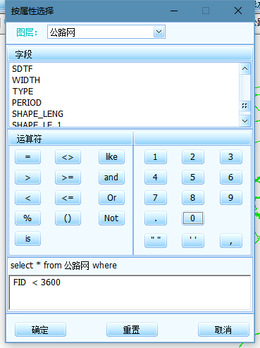
图 1 属性查询页面
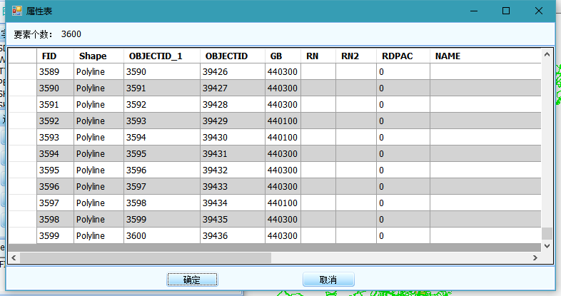
图 2 查询结果
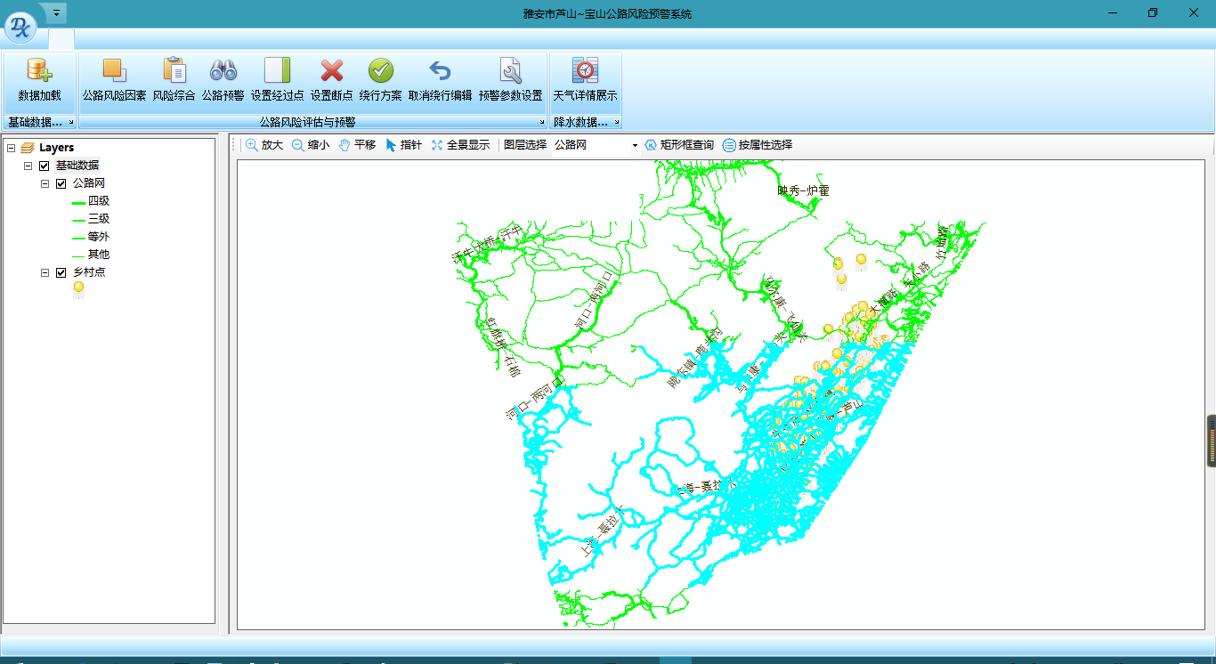
图 3 空间查询
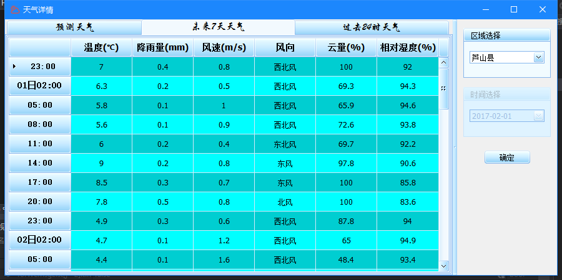
图 4 天气数据展示1

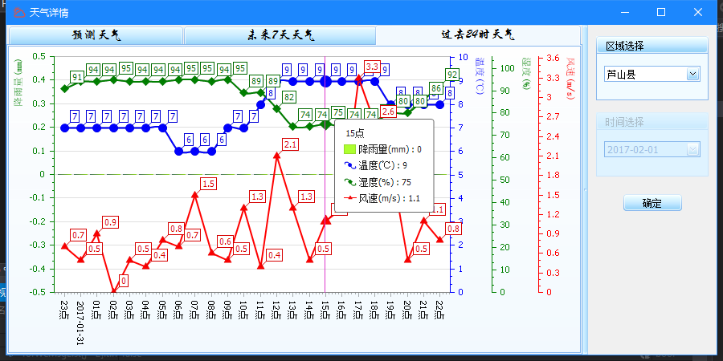
图 5 天气数据展示2
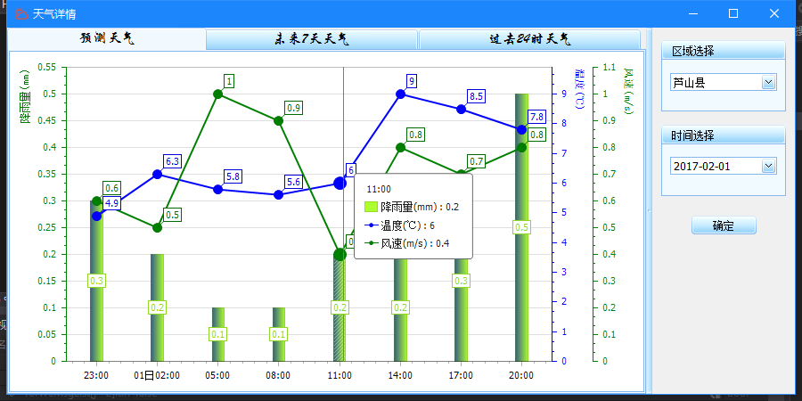
图 6 天气数据预测
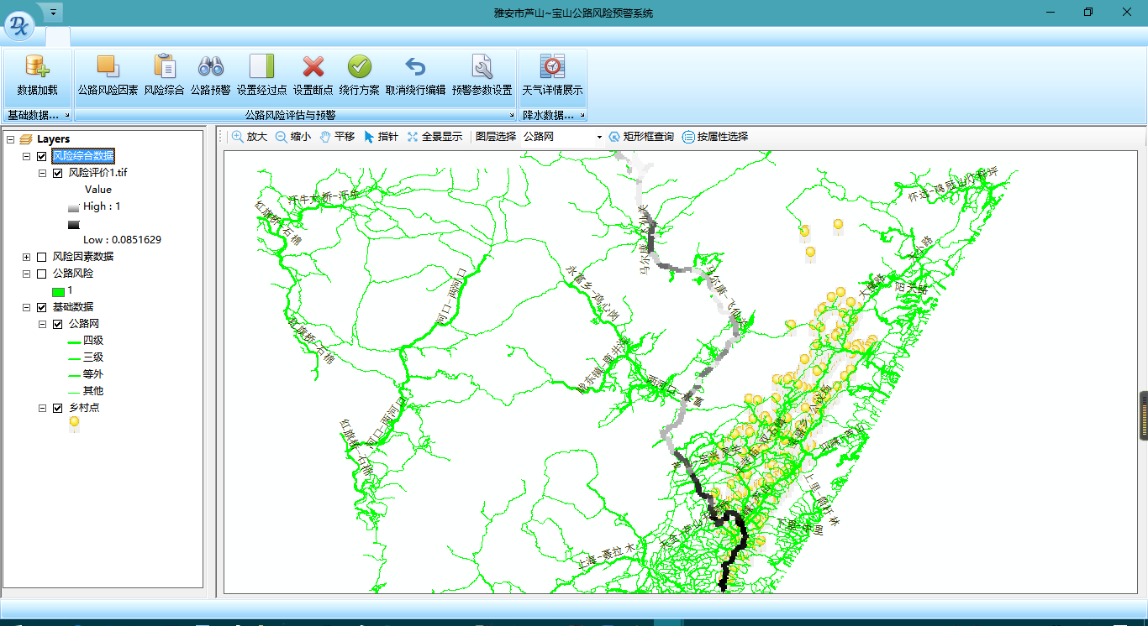
图 7 风险综合数据
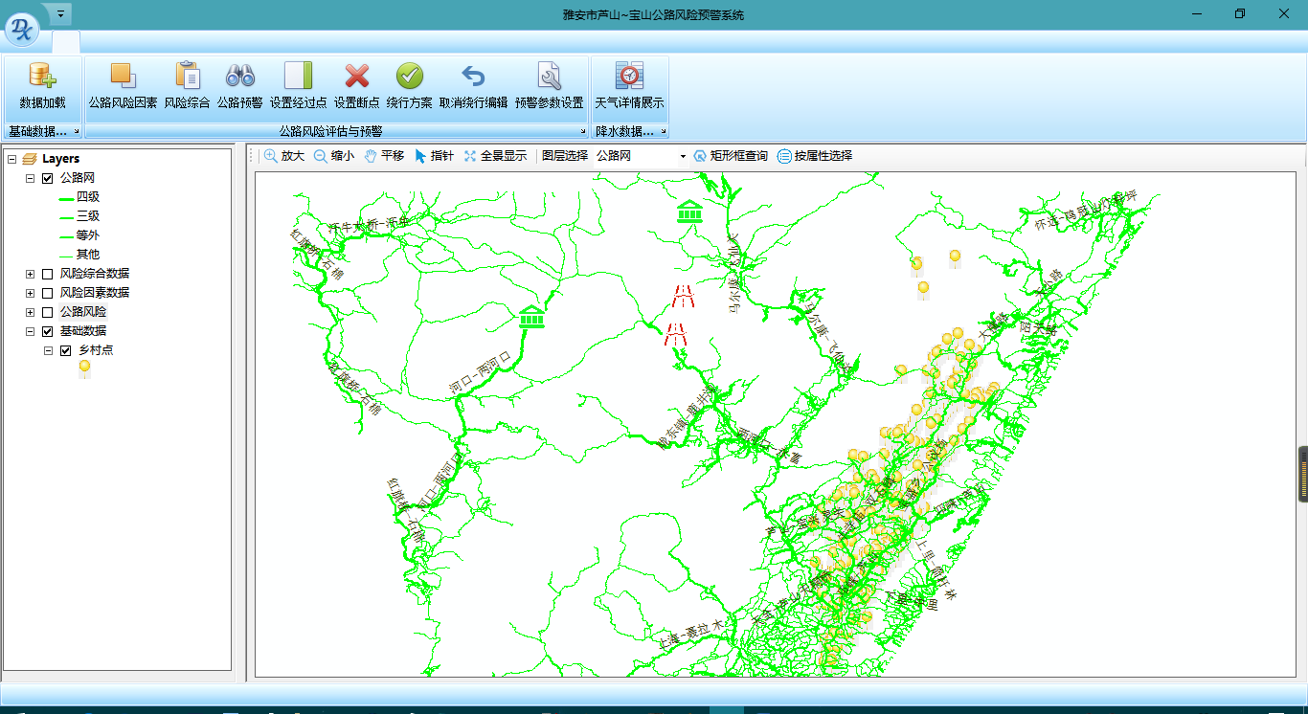
图 8 公路绕行之添加障碍点和经过点
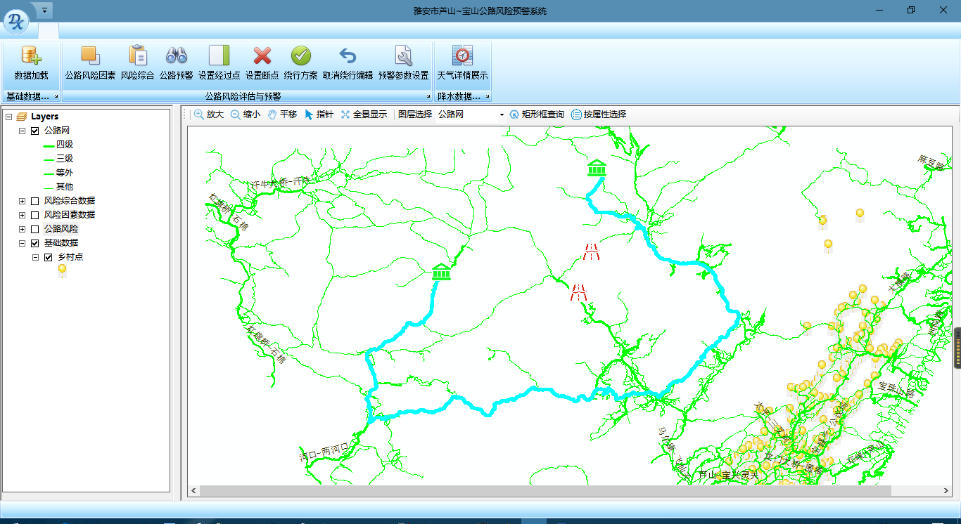
图 9 绕行线路结果
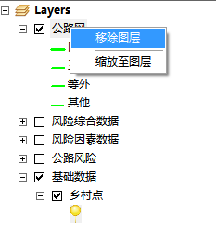
图 10 图层控件操作
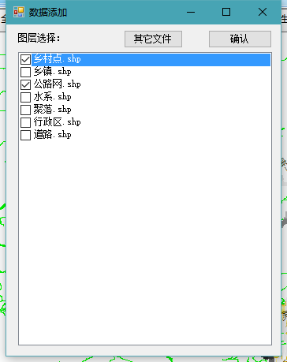
图 11 数据添加
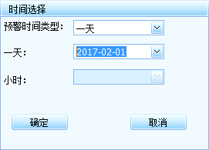
图 12 预警时间设置
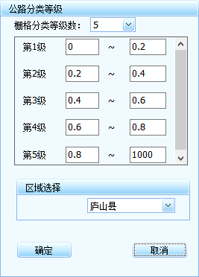
图 13 公路分类等级设置
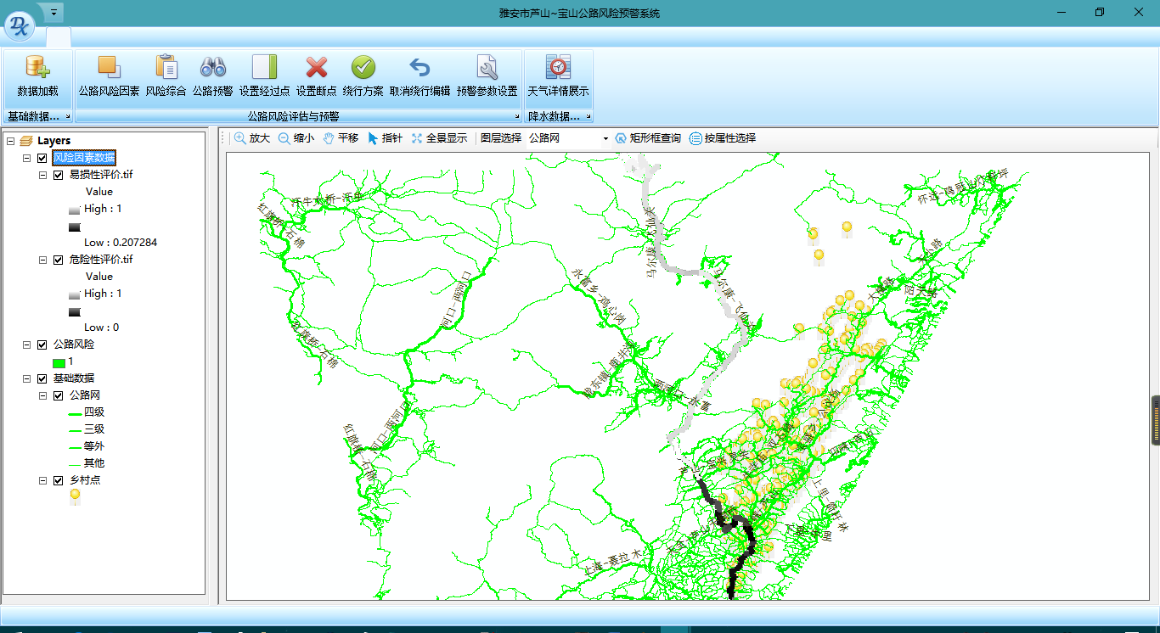
图 14 预警结果

六.不足与展望
….

